BNSI Processing Error alarm LLD
Version | Date | Author | Description
0.0 | 16th Nov 2011 | Chris Janes | Original

Description
This doc describes the updates to be made in the BNSI rules files / Impact Policy for the Processing Error alarms generated by BNSI nodes.

HLD:
BNSI Process Error alarms should generate a TT for each instance of the alarm that occurs, after a specified waiting time.

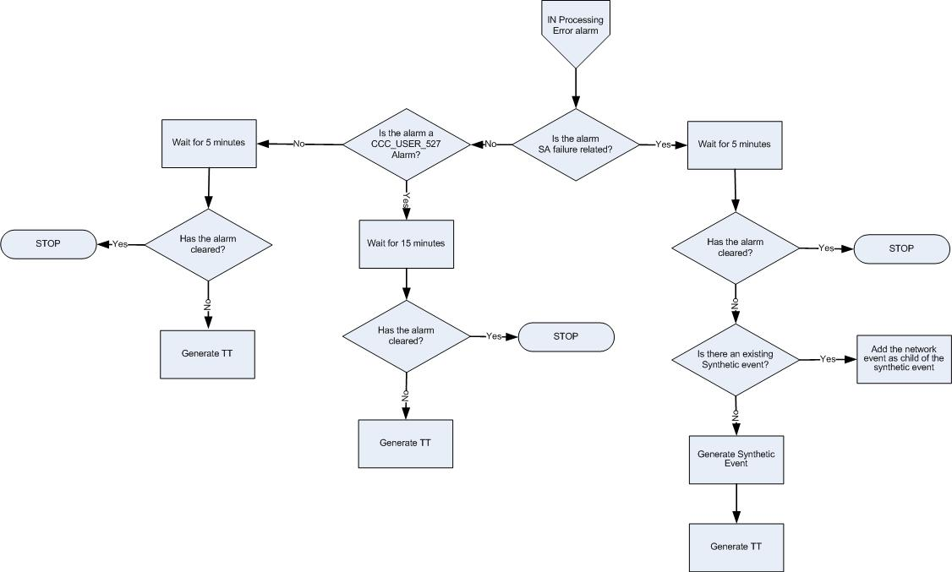

BNSI Processing Error alarm handling Flow Chart

Pre-requisite
- Map added into TSRM between EventId “NET_IN_PER_001” and classification “PROCESSING ERROR ALARM”
- Map added into TSRM between EventId “SYN_IN_PER_001” and classification “PROCESSING ERROR ALARM”
- Map added into TSRM between EventId “NET_IN_PER_003” and classification “PROCESSING ERROR ALARM”
- The TTHibernate field was added to the ObjectServer schema
- ML_RaiseTT_FirstOccurrence trigger was added in the ObjectServer

Event Filter:
No. | Alarm description | Domain | Field | Value | EventId
1 | BNSI Processing Error alarm | BNSI | Summary | CCC_USER_527:Performance degradation of process instance CCC_USER_527 due to failed locality optimization.  Matching condition:  regmatch(@Summary, ".*Performance degradation of process instance CCC_USER_527 due to failed locality optimization") | NET_IN_PER_001
2 | BNSI Processing Error alarm | BNSI | Summary | OEM:inxxcey:LOG3.012662978571080028 15 2 10 4.1A30 SMAWsf : SA SA_pprcir.so to test host inxxcey failed  Matching condition:  regmatch(@Summary, "OEM.* SA .* to test host .* failed") | NET_IN_PER_002
3 | BNSI Processing Error alarm | BNSI | Summary | OEM:inxxcey:LOG3.The SA SA_scon to test host inxxcey has exceeded its configured timeout, pid 7741 will be terminated  Matching condition:  regmatch(@Summary, "OEM.* SA .* to test host .* has exceeded its configured timeout, pid .* will be terminated") | NET_IN_PER_002
4 | BNSI Processing Error alarm | BNSI | Summary | inxxcey:inxxcey: UDP connection failed for LAN IP address [IP ADRESS ]  Matching condition:  regmatch(@Summary, ".* UDP connection failed for LAN IP address .*") | NET_IN_PER_003
5 | BNSI Processing Error alarm | BNSI | Summary | RtpEvtHdl01:connection to dispatcher 'RtpLogOracle01' disconnected,  Matching condition:  regmatch(@Summary, ".*connection to dispatcher .* disconnected") | NET_IN_PER_003
6 | BNSI Processing Error alarm | BNSI | Summary | OEM:in2ce1:816 - Spheras agent ssmProxy not running,  Matching condition:  regmatch(@Summary, "OEM.* Spheras agent ssmProxy not running") | NET_IN_PER_001
7 | BNSI Processing Error alarm | BNSI | Summary | RtpAccSam10:Failed to copy remote file  Matching condition:  regmatch(@Summary, ".*Failed to copy remote file") | NET_IN_PER_001
8 | BNSI Processing Error alarm | BNSI | Summary | RtpAccPam07:Slave RU failed [49-56] [EINTR] [ASYNC_ACK_TIMEOUT].,  Matching condition:  regmatch(@Summary, ".*Slave RU failed .*") | NET_IN_PER_001
9 | BNSI Processing Error alarm | BNSI | Summary | CheckBackup processing of the table voms.sxlogging_tab in thread  Matching condition:  regmatch(@Summary, "CheckBackup processing of the table .* in thread") | NET_IN_PER_003
10 | BNSI Processing Error alarm | BNSI | Summary | BRAlarm: Backup failed: /opt/nsr/nsr_backup_part_exec.sh VOMS2 exit code: 1  Matching condition:  regmatch(@Summary, "BRAlarm.* Backup failed.* exit code.*") | NET_IN_PER_003
11 | BNSI Processing Error alarm | BNSI | Summary | BRAlarm: Backup failed, exit code: 1  Matching condition:  regmatch(@Summary, "BRAlarm.* Backup failed.* exit code.*") | NET_IN_PER_003
12 | BNSI Processing Error alarm | BNSI | Summary | DR:/export/home/omni/bin/dr: inxxcey inaccessible  Matching condition:  regmatch(@Summary, "DR.* inaccessible") | NET_IN_PER_003
13 | BNSI Processing Error alarm | BNSI | Summary | SmcfProcGroup_257:Error detected during execution of SM task inadvantage/pps0301/smt/dba01 (executin) on CE1. The task aborted its execution.  Matching condition:  regmatch(@Summary, "SmcfProcGroup.*Error detected during execution of SM task inadvantage.* The task aborted its execution") | NET_IN_PER_001

Data Types:
Name | Contents
OS_Status | Object Server

Logic:

BNSI processing error alarm received
- Assign EventID and Domain for relevant network alarms as defined in event filter section.
- For alarm 1 set TTHibernate=900 (seconds)
- For alarms 4 – 13 set TTHibernate=300 (seconds)
- Alarms 2 and 3 are processed by the ML_INProcessingError

If not cleared after TTHibernate time, raise a TT for the alarm (for alarms 1, 4 - 13).
- The ML_RaiseTT_FirstOccurrence trigger checks for TTHibernate>0, Severity>0 and CurrentTime-FirstOccurrence>=TTHibernate and sets the alarm for ticketing (@LogTicket=1).

THE STEPS BELOW APPLY ONLY FOR ALARMS 2 & 3.
THEY ARE TO BE PERFORMED IN THE ML_INProcessingError IMPACT POLICY.

Wait for 5 min / Has the alarm cleared?
- Hard-code a sleep period of 5 minutes and then check if the alarm still exists and is not cleared (Severity>0)

Is there an existing BNSI processing error synthetic event for the NE?
- Check for alarms with the same @NodeAlias, @EventId=’SYN_IN_PER_001’ and same SA identifier (e.g. SA_scon) in the Summary
- If found, add the current network event as a child of the existing event via the journal. Set the @SyntheticServerSerial for the network event equal to the synthetic event @ServerSerial.
- Update the severity of the synthetic event based on the severity of the most recently added network event.

If not found, generate new synthetic BNSI processing error event
- If no existing synthetic event found, create a new synthetic event with the current event added as a child (journal entry). Populate @SyntheticServerSerial of the network event with serial of the synthetic event.

Field Name | Value
Node | @Node
NodeAlias | @NodeAlias
Summary | IN SA Processing errors
AlertGroup | @AlertGroup
Agent | Netcool Impact
Manager | Netcool Impact
Severity | 5
Type | 1
LogTicket | 1
ImpactFlag | 6
MaintFlag | @MaintFlag
EventId | SYN_IN_PER_001
Class | 200041
Site | @Site
SiteCode | @SiteCode
Identifier | Node + Summary + Type + EventId + <@LastOccurrence from network event>
FirstOccurrence/ LastOccurrence | getdate()
Domain | @Domain
Region | @Region
ManCity | @ManCity
CovCity | @CovCity
OutsourceContractor | @OutsourceContractor
BusImportance | @ BusImportance
Vendor | @Vendor
BSC_Name | @BSC_Name
BTS_Name | @BTS_Name
AdvCorrServerSerial | @Serial
OmcEms | @OmcEms

Resolution of events
EventId | Resolution mechanism
NET_IN_PER_001 | Clearance of the network event is managed by the ML_ClearResolved trigger after TSRM gateway sets the TicketStatus to RESOLVED.
NET_IN_PER_002 | Clearance of the network event is managed by the ML_ClearNetworkEvent policy when the parent synthetic event is cleared upon ticket resolution.  NOTE: the EventId is to be added in the ML_ClearNetworkEvent policy
NET_IN_PER_003 | Clearance of the network event is managed by its resolution event.
SYN_IN_PER_001 | Clearance of the synthetic event is managed by the ML_ClearResolved trigger after TSRM gateway sets the TicketStatus to RESOLVED.  NOTE: the EventId is to be excluded from the ML_ClearSyntheticEvent policy

